Disney Entertainment Empire
Unison Park

Introduction
The entertainment industry is a diverse and rapidly evolving sector that includes film, television, music, streaming services, video games, and live events. Beyond traditional media, theme parks have become major cultural and economic landmarks, offering immersive experiences. A key player in this space is The Walt Disney Company, a leading diversified international family entertainment and media enterprise with major business segments: media networks, parks and resorts, studio entertainment, consumer products, and interactive media.
Figure 1: Stacked bar chart of Disney company revenue (in billions of dollars) per segment per quarter.
In 2023, Disney revised its financial reporting structure, introducing sports including ESPN as a standalone segment. In Figure 1, a stacked bar chart showing Disney’s revenue by segment per quarter, illustrates both this new categorization of Disney’s financial foundation. As digital platforms expand access to entertainment, physical spaces like theme parks continue to thrive by delivering unique, real-world experiences that can’t be replicated on a screen. Together, these various branches of entertainment shape global culture, influence public imagination, and contribute significantly to the world economy. I argue that Disney is the most dominant and versatile force in global entertainment.
The Origins and Growth
Walt Disney, born in 1901, was a visionary animator, entrepreneur, and voice actor who revolutionized the entertainment industry. In 1923, he co-founded the Disney Brothers Studio with his brother Roy O. Disney, which would later become The Walt Disney Company. Their first major success came with the creation of Mickey Mouse in 1928, a character that quickly became a cultural icon. Disney continued to innovate with the first full-length animated feature film, Snow White and the Seven Dwarfs (1937), which set a new standard for animation.
Throughout the mid-20th century, Walt Disney expanded his company into new areas, including television, merchandise, and—most notably—theme parks. After Walt's death in 1966, the company continued to grow, opening Walt Disney World in Florida in 1971 and eventually expanding internationally.
Cultural Dominance Through Awards
Walt Disney’s legacy at the Academy Awards is unparalleled, beginning with his wins in the early 1930s. In 1932, Disney made history at the Fifth Annual Academy Awards when Flowers and Trees, the first cartoon produced in Technicolor, won the inaugural Oscar for Best Short Subject (Cartoon). That same night, he also received a special Academy Award for the creation of Mickey Mouse, an iconic character in film history. For many years, Disney was the only studio to receive such consistent recognition, with other animation studios not earning multiple Oscars until much later. In figure 2, Walt Disney won a record-setting 32 Academy Awards.
Figure 2: Line graph comparing academy award wins over time Across major animation studios
To emphasize Disney’s dominance and illustrate how rare it was for other studios to reach similar heights, it's worth noting that only a small number of animation studios have ever earned more than one Oscar. This pattern of consistent recognition shows Disney’s unique ability to blend compelling storytelling, technological innovation, and emotional appeal.
Box Office Supremacy
In 2024, The Walt Disney Company solidified its position as a dominant force in the global box office, capturing over 30% of the market share and grossing $2.2 billion, a 17% increase over 2023. This impressive total came from 30 titles, including both new releases and carryovers, with major contributions from Pixar, Marvel Studios, and 20th Century Studios. Disney became the only major studio to surpass $2 billion in the post-COVID era, and the only studio to release two $1B-plus films in 2024—Inside Out 2 ($652.9M), the highest-grossing title of the year, and Deadpool & Wolverine ($636.7M). Even 20th Century Studios saw success with reboots like Kingdom of the Planet of the Apes ($171.1M) and Alien: Romulus ($105.3M), while Searchlight’s Bob Dylan biopic added another layer of appeal, bringing older audiences back to cinemas with $28.4M since Christmas.²
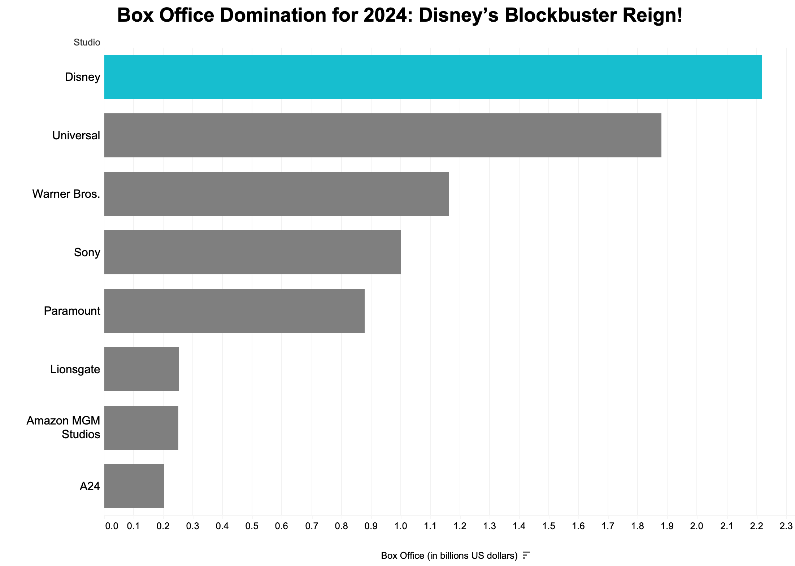
Figure 3: Bar chart displaying the top studios by highest box office revenue (in billions of dollars) in 2024
Disney’s revenues come not only from films but also from parks, streaming, merchandise, and licensing—an ecosystem designed for longevity and resilience.
Consumer Products and Licensing Power
In 2023, Disney reaffirmed its dominance in the global licensing market, topping the licensor rankings with an estimated $61.7 billion in retail sales, according to License Global. This staggering figure reflects the immense power of Disney’s brands, including Star Wars, Marvel, Pixar, and Disney Princess, which have become cultural icons recognized worldwide. Disney’s licensing empire spans an extensive range of consumer products, from clothing and toys to collectibles, home goods, and even food and beverages. These brands have permeated every corner of the global market, capturing the imaginations of audiences across generations.
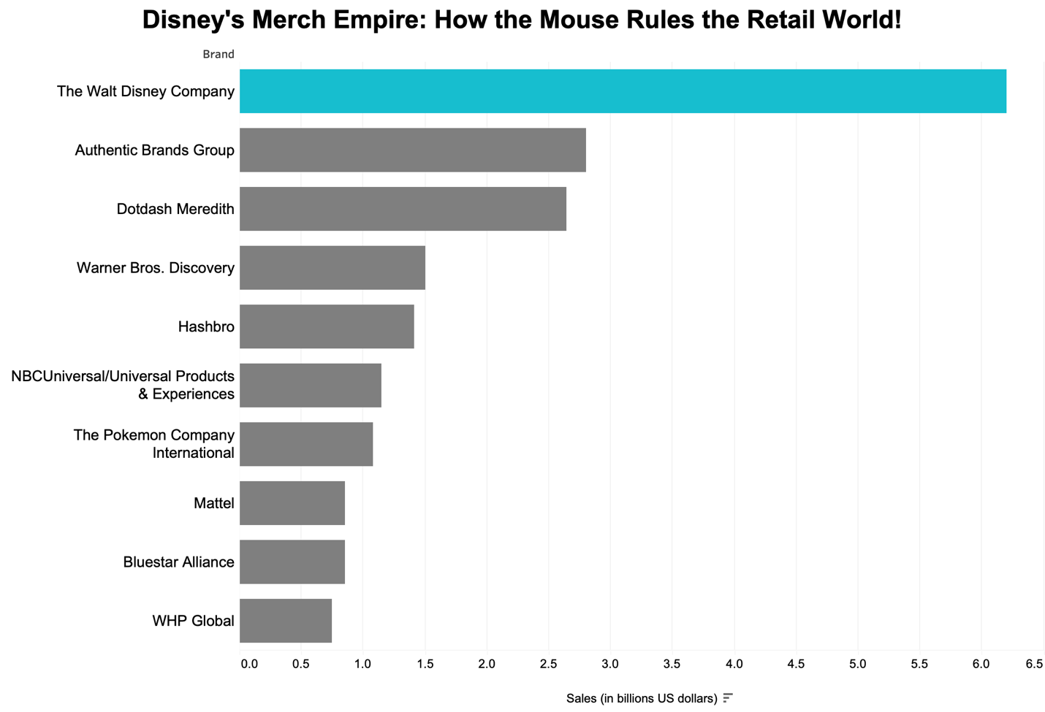
Figure 4: Bar chart displaying the top licensure companies by highest retail sales (in billions of dollars) in 2023
Disney’s licensing strategy is rooted in its ability to create products that not only resonate with fans but also tap into the nostalgia and emotional connections people have with their favorite characters and stories.

Theme Park Appeal
Disney’s theme park empire began in 1955 with the opening of Disneyland in Anaheim, California. Created by Walt Disney himself, Disneyland was the first-ever theme park designed to immerse guests in a world of fantasy and adventure, setting a new standard for the industry. The park, which opened on July 17, 1955, was a revolutionary concept at the time, blending entertainment, storytelling, and cutting-edge technology to create an experience unlike anything seen before. Walt Disney’s vision was simple: to create a place where families could enjoy quality time together while exploring imaginative, themed environments that brought Disney's beloved characters and stories to life. Disneyland quickly became a cultural phenomenon, attracting millions of visitors each year and paving the way for future parks in other locations. Following the success of Disneyland, Disney expanded its global reach with iconic parks such as Walt Disney World Resort in Florida (opened in 1971), Tokyo Disneyland (1983), and other international locations. In 2023, Disney's Magic Kingdom in Florida continued to reign as the most visited theme park globally, hosting over 17 million guests.
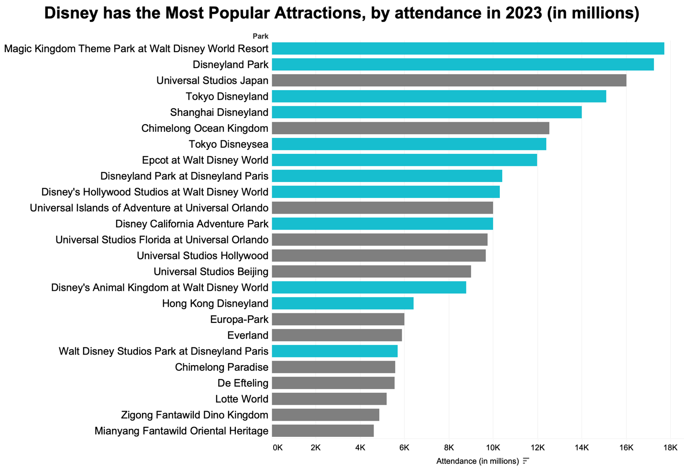
Figure 5: Bar chart of the most popular attractions in the world by attendance (in millions) 2023
Over half of the parks highlighted in blue in Figure 5 are owned by Disney. Alongside other consistently high-performing Disney parks like Disneyland and Tokyo Disney Resort, these destinations have become fully immersive brand experiences that attract millions of visitors annually. Disney ensures that its parks remain at the forefront of the global tourism industry, inviting new generations to experience the magic and continue the legacy that began over six decades ago.
Conclusion
Through its achievements in film, product licensing, entertainment, and global box office success, Disney has emerged as the most dominant force in global entertainment. As media continues to grow, Disney's trajectory offers a case study in both innovation and corporate power. Audiences and industry professionals alike must understand how one brand can influence so much of what the world watches, wears, and visits.

References
- Academy of Motion Picture Arts and Sciences. (n.d.) Awards. Database. Retrieved on April 11, 2025, from https://awardsdatabase.oscars.org/
- Deadline. (2025, January 3). Box office 2024: Studio market share. Retrieved on April 11, 2025, from https://deadline.com/2025/01/box-office-2024-studio-marketshare-1236244785/
- License Global. (2023). Top 150 leading licensors. Retrieved on April 11, 2025, from https://www.licenseglobal.com/rankings-lists/top-150-leading-licensors
- Statista. (2023). Leading amusement and theme parks worldwide 2023, by attendance. Retrieved on April 11, 2025, from https://www.statista.com/statistics/194247/worldwide-attendance-at-theme-and-amusement-parks/
- Stock Analysis. (n.d.). Walt Disney revenue by segment. Retrieved on April 11, 2025, from https://stockanalysis.com/stocks/dis/metrics/revenue-by-segment/

